***Southwest***

***Software***

*** Development***

***Team***

**Second Year Computing Project**

**2011/2012**

**Fully Automated Payroll System**

**Planning**

**Design & Development Team:**

**James Madden: X00086390:**

**Project Manager, Customer Liaison, Software and Database Development, System Testing & Quality Control.**

**Shane Murphy: X00085315:**

**System Design, Software and Database Development, System Testing & Quality Control.**

**Maciej Macierzynski: X00086366:**

**System Design, Software and Database Development, System Testing & Quality Control.**

Table of Contents

**List of Figures and Tables** 3

**Introduction** 4

**Introduction:** 5

**Background to the project, business context, justification, etc:** 5

**Overview of the project:** 5

**Project deliverables:** 5

**Evolution of Software Project Management Plan (SPMP):** 5

**Reference materials:** 5

Definitions and Acronyms: 5

**Project Organisation** 7

**Organisational structure:** 8

**Team skills:** 8

**Project responsibilities:** 8

**Managerial Process** 9

**Management objectives:** 9

Assumptions, dependencies and constraints: 9

**Risk management:** 9

**Monitoring and controlling mechanisms:** 9

**Technical Process** 10

**Methods, tools and techniques:** 10

PL/SQL 10

**Software documentation:** 12

Software Project Management Plan 12

Software Quality Assurance Plan 12

Software Design Documentation 12

Testing Documents 12

Feasibility Report 12

User Maintenance Manual 12

Project History 12

**Project support functions:** 13

**Work Elements, Schedule and Budget** 14

**Work packages:** 14

**Dependencies:** 14

**Resource requirements:** 14

**Budget and resource allocation:** 15

**Schedule:** 16

**Schedule Table:** 16

**Gantt Chart** 17

**Network Diagram:** 18

# **List of Figures and Tables**

Figure 1 Process Model 9

Figure 2 Organisational Structure 10

Table 1 Project Responsibilities: 9

Table 2 Tools: 11

Table 3 Budget: 15

# **Introduction**

## **Introduction:**

The project team will undertake the design and development of a fully automated payroll system. The concept behind this project is to develop a system which lends itself to ease of use by nonqualified (financial) users.

## **Background to the project, business context, justification, etc:**

The general consensus among trade’s people, small business owners and the self employed in all sectors would be there is a requirement for a system which is easy to learn and use, is fully automated, it requires minimum time and effort to administer on a weekly/monthly basis.

## **Overview of the project:**

The system once initially setup will automatically generate payslips on a weekly or monthly basis and e-mail these payslips to the employees, it will transfer funds to the employee’s bank account on a weekly or monthly basis as required. The system will also generate the relevant forms and returns as required by the revenue commissioners and social welfare, such as P35’s and P60’s returns and form P45. The appropriate funds will be transferred as required on a monthly and yearly basis to the relevant bank accounts.

## **Project deliverables:**

* Project outline Plan 11/11/2011
* Feasibility Study 13/02/2012
* User Requirements, Specification and Object Model 13/02/2012
* Design Specification, Test Plan and Class Diagram 27/02/2012
* System Prototype 23/04/2012
* Completed System Tests and Test Results 23/04/2012
* User Manual 23/04/2012
* Interview and presentation, of the completed system 30/04/2012

## **Evolution of Software Project Management Plan (SPMP):**

Following on from the initial design, during the development of the system, team members may propose additions or modifications to the proposed design. These proposals will be studied and fully discussed by the team and may be implemented if agreement is reached by the entire team.

## **Reference materials:**

Java.sun.com

Core Java 2 vol1 Horstmann, Cornell 2005

Software Engineering Roger S Pressman 2005

# Definitions and Acronyms:

PDDT Project Design & Development Team

OO Object Oriented

RAD Rapid Application Development

SDLC System Development Life Cycle

URS User Requirements Specification

SPMP Software Project Management Plan

SCMP Software Configuration Management Plan

SQAP Software Quality Assurance Plan

SVVP Software Verification & Validation Plan

WP Work Packages

# **Project Organisation**



Figure Process Model:

Above is a graphical representation of the process we intend to follow while developing the payroll system, here we are using the OO Process Model which maps the various stages of the development process.

## **Organisational structure:**



Figure Organisational, Structure:

Above is the graphical representation of the organisation of the PDDT. Although a project manager has been appointed, after an initial meeting and discussions it was decided by the PDDT that due to the compact nature of the team and the extremely close working relationship of the members it would be more beneficial to have the team work on a level (Flat) par with no hierarchy in place. A weekly meeting will be held to check progress, discuss difficulties and problems and plan the next stage of development.

**Team skills:**

Between the three team members of this team, the team can boast an excellent level of design, system analysis, programming, and database development skills. The skill set of the team, combined with a mature attitude and outlook, many years of industrial and commercial experience will prove invaluable in the development and success of this project.

**Project responsibilities:**

|  |  |  |  |
| --- | --- | --- | --- |
| Team Member | James Madden | Maciej Macierzynski | Shane Murphy |
| Feasibility Report | X | X | X |
| Project Plan | X | X | X |
| Analysis | X | X | X |
| Design | X | X | X |
| Coding | X | X | X |
| Testing | X | X | X |
| User Documentation | X | X | X |
| Training | X | X | X |
| Handover | X | X | X |

Table Project Responsibilities:

# **Managerial Process**

## **Management objectives:**

* To design a professional system which will meet customer requirements
* Is simple to learn and use
* Will be completed within the agreed time frame and budget

## Assumptions, dependencies and constraints:

* The ability of the team to perform to exacting standards
* The ability of the team to bring a quality project in on time and within budget
* Equipment and software will be available when required by the team
* Budget and time constraints remain unchanged

## **Risk management:**

In order to mitigate the risks of delay or total failure of the project, a Project Design and Development Team has been put together comprising three of the most dedicated team members whom have previously, worked well together, and poses all the required skills and commitment to complete this project to a very high standard, on time and within budget.

We are planning to work very closely together on all aspects of the project thereby mitigating any risks due to illness or other unforeseen difficulties.

To overcome the possible effects of severe weather conditions having an adverse affect on the project schedule we have chosen to work on this project with the aid of cloud computing, where all project files will be stored on the web and each team member will have access to these files 24/7.

## **Monitoring and controlling mechanisms:**

In order to monitor the progress of the project, a weekly meeting of the PDDT will be held where progress and test reports will be reviewed.

All revisions and amendments will be documented and recorded.

Any proposed changes or additions and there implications to the project schedule and/or cost will be fully discussed by the team and a decision on whether to include these proposals in the project at this stage will be taken.

# 

# **Technical Process**

## **Methods, tools and techniques:**

The operating systems available to the PDDT are Windows 7, Windows XP and Mac OSX Lion. The facilities in the college use Windows 7; as such the project will be designed to be compatible and configurable on the Windows 7 platform.

Our development language will be Java. This will be developed using the Eclipse IDE and will be linked to an Oracle database using the PL/SQL language.

Java is an object orientated language developed by Sun Microsystems in the 1990’s originally as a project called ‘Oak’, later renamed in 1995 to Java. Since then java has been tested, refined and extended to become a trusted development platform in the mainstream development environment, with a dedicated support community.

The design goals of Java were simple, it was to be:

1*. "Simple, object-oriented and familiar"*

*2. "Robust and secure"*

*3. "Architecture-neutral and portable"*

*4. "High performance"*

*5. "Interpreted, threaded, and dynamic"*

<http://java.sun.com/docs/white/langenv/Intro.doc2.html> Accessed 2/11/11

### PL/SQL

This refers to a Procedural Language/Structured Query Language developed by Oracle to access and manipulate its relational databases. It is an extension language of SQL which supports arrays, variables, conditions, loops and exceptions. This language has been around since the 1970’s, known as SEQUEL at first and developed by IBM. The name later changed to SQL and was commercially implemented by Oracle.

<http://download.oracle.com/docs/cd/B13789_01/server.101/b10759/intro001.htm>

|  |  |
| --- | --- |
| Project Plan | Microsoft Project 2007  Microsoft Visio 2007 |
| Software Development/  Programming Languages | Eclipse IDE  Java  Oracle SQL Developer 11g  PLSQL  Oracle Database Server |
| Collaborative Tools | DropBox  Google Docs |
| Text Editors | Microsoft Word 2007 |
| Communication | Mail  Outlook  Gmail |
| Compression | WinRar  Stuffit |
| Graphical tools | Microsoft Powerpoint 2011  Microsoft Visio 2007  Adobe Illustrator CS5 |

Table Tools:

The above software is critical for a smooth design and development period. The preparation and planning of the project will be mapped out in MS Project, where resources and time will be taken into account. Later in the development process, MS Visio will be used to plan our relational database tables. These tables will later be implemented using Oracle Developer and the PL/SQL language.

The PDDT found both DropBox and Google Docs useful in collaborating on projects in the past; they are seen as valuable tools in any group projects where schedule conflicts occur within the group. WinRar and Stuffit were used to create compressed files for transfer to memory sticks, upload to Dropbox and email attachments. Mail, Outlook and Gmail are also invaluable to the group’s communication outside of college.

Project and software documentation was constructed using MS Word, and Adobe Illustrator may be used for any diagrams deemed necessary.

**Software documentation:**

The following documents shall be produced and updated throughout the project:

### Software Project Management Plan

The SPMP is a broad plan that incorporates a project overview, summary, definitions, estimations, schedules, budgets, risk assessments and resource allocation plans. It is updated throughout the project detailing the projects evolution.

### Software Quality Assurance Plan

The SQAP is used to document the quality of work produced during each stage of the project. It ensures the project is finished to the high standards put in place and includes stated requirements. The contents of the SQAP include verification and validation documents, stage deliverables, assessments, deliverable class standards, and implementation and acceptance documents.

### Software Design Documentation

Software Design Documentation provides information on the overall goals and requirements, design overview, functional design, technical design and general issues encountered. Information flow, data handling and events are key sections of this document. The standards for the other documents are also defined here.

### Testing Documents

These documents refer to plans for, and the results of, testing carried out on the system. Typical components of these documents are case specifications, incident reports, test logs, test plans and test reports.

### Feasibility Report

This report rationally details the strengths and weaknesses of a proposed project, the contents of which should include the problems, opportunities, threats, resources required and prospects for success.

### User Maintenance Manual

This document is aimed at users as well as maintenance programmers. As such it is a thorough document written very clearly, outlining the structure and how the program works.

### Project History

A Project History report collects objective information about the work cycles of a project, it is comprised of team member’s personal impressions of what aspects of the development cycle worked well and which didn’t.

**Project support functions:**

The following tasks will be implemented to support the project:

**SQAP / Software Quality Assurance Plan**

**SPMP / Software Project Management Plan**

**SVVP / Software Validation and Verification Plan**

**SCMP / Software Configuration Management Plan**

Adherence to the above will be maintained throughout the projects lifetime. More information regarding these tasks may be found in section 4.2 Software Documentation.

# **Work Elements, Schedule and Budget**

**Work packages:**

The project is structured in five Work Packages (WPs) which correspond to the five main areas of system development. Each Work Package consists of subtasks that will be conducted by team members.

* Feasibility
* Analysis & Design
* Development
* Testing
* Documentation

-See diagrams of tasks list and project structure on page 14

**Dependencies:**

-See details on page 10

**Resource requirements:**

The software necessary to develop the system is the main resource needed. These are provided by the college or open source software/ freeware.

The hardware such as computers and printers are provided by the college. Also development team members’ personal computers and other equipment will be used outside the allocated college time when required.

Minimal expenses will be required to cover costs of printing documentation and project work storing.

-See budget detailed list on page 16.

**Budget and resource allocation:**

|  |  |  |  |
| --- | --- | --- | --- |
|  |  | **Details** | **Cost** |
|  |  |  |  |
| **Software** |  | Microsoft Windows 7 | N/A |
|  |  | Microsoft Project 2007 | N/A |
|  |  | Microsoft Office 2007 | N/A |
|  |  | Microsoft Visio 2007 | N/A |
|  |  | Eclipse IDE | N/A |
|  |  | Oracle Database Server | N/A |
|  |  | Oracle SQL Developer 11g | N/A |
|  |  | WinRar | N/A |
|  |  | Stuffit | N/A |
|  |  |  |  |
| **Hardware** |  | PCs/Laptops | N/A |
|  |  | Printer | N/A |
|  |  | USB Memory Sticks | N/A |
|  |  | Blank CDs | 10e |
|  |  |  |  |
| **Staff** |  | Training | N/A |
|  |  | Analysis | N/A |
|  |  | Design | N/A |
|  |  | Development | N/A |
|  |  | Testing | N/A |
|  |  | Presentation | N/A |
|  |  |  |  |
| **Other expenses** |  | Printer paper | 5e |
|  |  |  |  |
| **Total Cost** |  |  | **15e** |

Table 3 Budget:

# **Schedule:**

## **Schedule Table:**

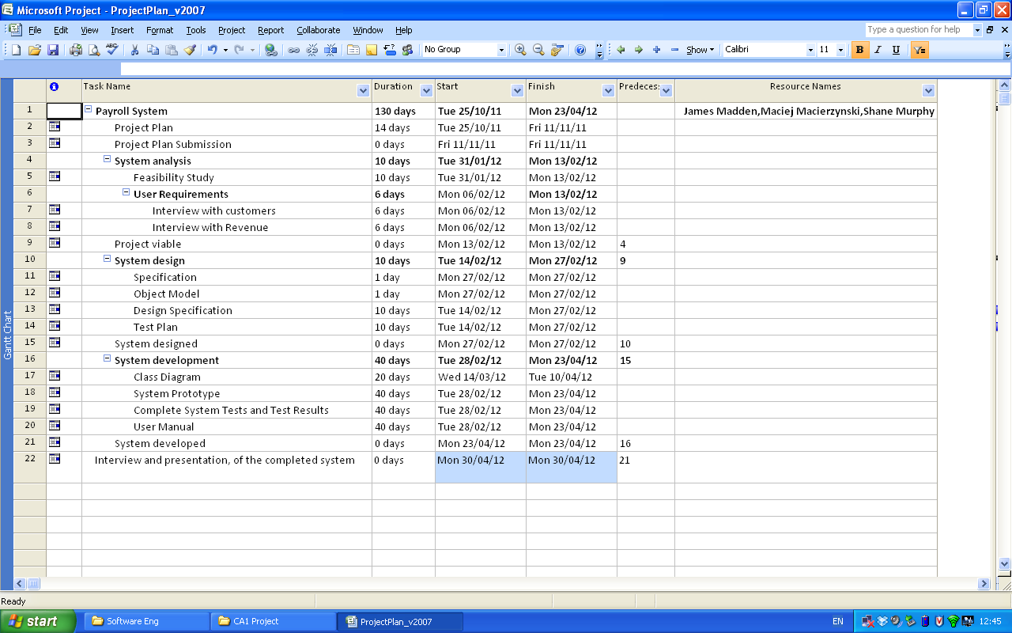

## **Gantt Chart**



# 

# **Network Diagram:**

